INVERTED PENDULUM

**GROUP MEMBERS**

   NAME                                        EMAIL ID                                         PHONE NO.

Sonam Motwani                   [rhythm2503@gmail.com](mailto:rhythm2503@gmail.com)                             9920734611

Mudit Dandwate                  [mudit.dandwate@gmail.com](mailto:mudit.dandwate@gmail.com)                      9769739682

Sushant Agarwal                  [sushantiitb@gmail.com](mailto:sushantiitb@gmail.com)                               9594573078

**MENTORED BY** :**Manav Kataria**

We propose to make an Inverted Pendulum which is a pendulum having its mass above its pivot point.

The problem involves a cart, able to move backwards and forwards, and a pendulum,

hinged to the cart at the bottom of its length such that the pendulum can move in the

same plane as the cart, shown below. That is, the pendulum mounted on the cart is free

to fall along the cart's axis of motion. The system is to be controlled so that the

pendulum remains balanced and upright, and is resistant to a step disturbance.

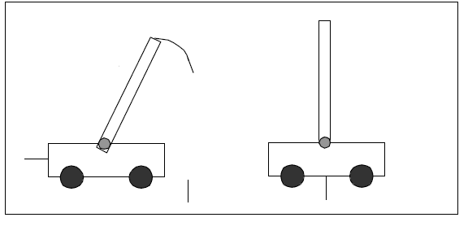

An inverted pendulum is inherently unstable, and must be actively balanced by moving the pivot point horizontally as part of a feedback system.

To mount the pendulum following can be used :

* a cart
* sliding platform
* rotating platform

Out of these we have thought of using a cart.

To obtain data concerning the angle of rotation of the pendulum,potentiometer,accelerometer and gyroscopes are the possible options.

As of now we will use potentiometers considering the convenience. Once we are successful with this mechanism we will proceed with accelerometers.

For processing we will use AVR Microcontrollers.

REAL LIFE EXAMPLES

* Missiles and rockets
* Self balancing robots
* Future transport vehicles-Segways